FERAL CREATIVE
Brand Audit & Strategic Positioning Report
The Greenlight Movement
Pre-Rebrand Assessment & Strategic Direction · 2026–2027 Runway
Includes website autopsy, homepage video audit, testimonial reframing and peer website audits
October 2026

Executive Summary & Core Brand Mandate

The Immediate Brand Mandate: Retiring "The Greenlight Office"
- The Greenlight Office currently names the LinkedIn company page and appears in testimonials as an administrative backstop or support desk. "Office" connotes bureaucracy, administration, administrative overhead, and static service delivery.
- The Greenlight Movement represents the collective ambition, the network of 165+ member organisations, the shared momentum of eradicating poverty, and the active learning community.
Strategic Mandate:
- Unify under a single master brand: The organisation will be known exclusively as The Greenlight Movement.
- Deprecate "The Greenlight Office": Remove "Office" from all public platforms, communications, and social handles. Any legal or trust registration entities should be confined strictly to formal legal footers and audited financial statements.
- Elevate from Service Provider to Sector Catalyst: Pivot public messaging from "We execute surveys and measure impact" to "We walk alongside changemakers on a proven learning journey to build capability, drive deep impact, and create lasting social change."

Deliverable 01: Discovery & Research

1.1 Internal Reality vs. Public Presence (The 2023–2026 Shift)
The gap between what Greenlight actually achieves internally and what is visible online is vast. A review of internal operational data (as captured in the 2026 Member Presentation) reveals an organisation operating at a level of rigor far beyond what its public assets convey:
Dimension | Outdated Public Perception (Channels) | Current Internal Reality (Member Data 2026)
Identity | Survey execution partner / M&E software provider | Relational learning partner & capability builder
Focus | "Wide growth" (maximizing baseline survey counts) | "Deep impact" (quality, depth, longitudinal learning)
Member Retention | 22% second-survey completion (2023) | 79% second-survey completion across 165 members (2026)
Data Scale | Vague references to "140+ organisations" | 115,000+ surveys conducted, 165 active members
Reporting Output | Generic templates / raw dashboards | 161 total formal reports produced (134 baseline, 67 impact reports)
Operational Standard | Open access for anyone wanting surveys | Strict 5-Point Fit for Purpose screening & 7-Step Accompanied Journey

1.2 Digital Touchpoint Audit

A. Website (www.greenlightmovement.org.za)
A comprehensive deep-dive audit of the three primary conversion and authority pages—The Home Page, The Members Page, and The Impact Page—reveals critical visual, strategic, and messaging breakdowns:

1. The Home Page Autopsy (The Front Door Disconnect)
- Hero Section & Navigation:
  - No Primary Conversion Funnel: There is literally zero primary Call to Action (CTA) above the fold. A prospective funder, NPO executive, or government partner has nowhere to click to "Join the Movement", "Partner With Us", or "Explore the 7-Step Journey".
  - Deficit & Pity Framing: Copy leads with "scarcity/dependency mindsets" and "struggling or stuck in their life situations", framing participants through what they lack rather than their agency, resilience, and capability.
  - Clinical & Academic Definition: Defining Greenlight as "a social methodology + various metrics that provides a way to measure social impact" reduces the organisation to an academic calculator or survey vendor, completely concealing the 24-month relational learning journey and member community.
  - Metric Clashes: Cites "170+ non-profits, social enterprises, and businesses", contradicting the recent 165 member count and other digital channels.
  - Visual Diagnosis: A somber, pure black hero block paired with a gloomy black-and-white photo feels mournful and clinical rather than energising, hopeful, or movement-driven. A dense wall of unformatted text in tiny font causes high visitor bounce rates.
- The Video Feature ("The Greenlight Approach", YouTube: T29e_9tyvIM):
  - Runtime & Engagement Fatigue: At 5 minutes 16 seconds, the video is far too long for a modern homepage explainer (where the industry benchmark for B2B/institutional visitors is 60–90 seconds). With only 756 views and 14 likes over 3.5+ years, it experiences massive audience drop-off.
  - The Script Actively Creates the Name Confusion: The voiceover explicitly codifies the split identity:
    - "This is the Greenlight Movement and it has been in existence since 2015..."
    - Followed immediately by: "It's the job of The Greenlight Office to support the Greenlight Movement..." and "The Greenlight Office has over 40,000 assessments in the system..."
    - Instead of presenting one unified brand, the script forces viewers to mentally navigate an internal administrative distinction between an "Office" and a "Movement".
  - Outdated, Understated Scale: The script cites "over 130 organisations" (vs. 165+ today) and "over 40,000 assessments" (severely understating their real volume of 115,000+ ground-up surveys by nearly 3x). It completely omits their modern 79% retention rate and 161 analytical reports.
  - Visual Clipart vs. Human Soul: Despite discussing deep human themes (facilitators "holding space without judgment", longitudinal 12/24/36-month tracking), the visuals are generic and the style of graphics and titles is inconsistent.
- The Methodology & "Unusual Approach":
  - Self-Undermining Copy: Calling their own framework "an unusual methodology" undermines authority and scientific credibility in front of serious institutional funders and CSI heads.
  - Live Grammatical Typo: Body copy contains unedited errors ("...you can assesses a family's quality of life").
  - Visual Diagnosis: The jumping stick figure with a spiral of multicolored dots resembles a primary school wellness campaign rather than a high-level institutional impact movement.
- The Process Diagram:
  - Contradicts Internal Frameworks: Displays a dated 5-stage graphic (defining poverty → self-diagnosis → planning change → experiencing transformation → mapping impact) that directly contradicts the leadership’s new 7-Step Member Learning Journey.
  - Visual Diagnosis: Uses tilted 3D floating cards with heavy drop shadows and miniaturised, completely unreadable micro-text screenshots of survey tables.
- Testimonials & Social Proof (Structural & Copy Breakdown):
  - Death by Italics: Illegible italic quotes no one will read because it hurts too much.
  - Unrelated Imagery: The image should either be relevant to the quote or there should be no image at all — an unrelated image is confusing.
  - Excessive Length & Reading Fatigue: The testimonial is a dense, 120-word continuous italicised block that visitors skim past.

2. The Members Page Autopsy (Wasting Core Credibility)
- Introductory Positioning:
  - Vague value proposition defining membership as "adopting the philosophy of this innovative approach", with no mention of formal analytical reports, facilitated reflection cycles, or longitudinal retention benchmarks.
  - Tacks on an amateurish footnote: "Countries outside of South Africa: In 2023 we started assisting outside our country's borders (Uganda, Namibia). Send us an email."
  - Displays a casual conference snapshot and a broken, non-interactive map thumbnail with poor-contrast lime typography.
- The Member List ("The Terms & Conditions Effect"):
  - Wastes Premier Institutional Assets: Boasts premier partners—including Allan Gray Orbis Foundation, Old Mutual Foundation, The Jobs Fund, Industrial Development Corporation (IDC), Sappi, Massmart, Food Lover's Market, and Habitat for Humanity—yet buries them in an unformatted, 1,000-word plain-text dump separated by bullet dots.
  - Lacks logos, sector filters, case studies, or linked impact stories.
- Membership Criteria & Conversion Funnel:
  - Directly Contradicts the 5 Fit-for-Purpose Criteria: Replaces intentional readiness with bureaucratic requirements ("Eradicate poverty for 2-3 indicators", "Annual payment of membership fees and survey surcharges").
  - Legacy Name Reappears: Criterion #2 explicitly mandates: "Signing a MoU with The Greenlight Office".
  - Visual Diagnosis: 2000s-era green PowerPoint SmartArt chevrons paired with clashing mustard-yellow and lime buttons.
- The "IMPORTANT" Warning & Referral Network:
  - Leads with an aggressive, defensive tone using giant yellow hazard exclamation icons (! !) and all-caps warnings.
  - Explicitly introduces the retired acronym "TGO" (The Greenlight Office) and admits that "The referral pathway network operates informally", making an invaluable ecosystem sound makeshift.

3. The Impact Page Autopsy (The Data Vacuum)
- Headline & Global Footprint:
  - Answers a Question About Impact with Zero Impact: Literally asks "What has the impact been?"... yet provides zero concrete impact numbers (no mention of 115k+ surveys, 79% retention, or 161 analytical reports).
  - Defers Credibility to the Future: Closes with: "We can't wait to see the big picture of South Africa. We'll keep you posted."—sounding like an unproven startup rather than an organisation operating for over a decade.
  - Identity Confusion: Leads with a global map of Poverty Stoplight's international footprint (USA, UK, China, South America), distracting from Greenlight's unique African accompanied model.
- "The Benefits" & The Jigsaw Puzzle Graphic:
  - Patronising Deficit Copy: Bullet #2 under Beneficiaries claims the tool "Contrasts 'poor' with 'not poor' – enables people to understand the ways in which they are poor."
  - Core Copy Typo: States that it "Provides line of site to way out of poverty" (spelling error: site instead of sight).
  - Refers to Participants as "Clients": Turns human development into transactional service delivery.

B. LinkedIn Presence ()
(Audit conducted by Glynis Abrahams, Connectiv Communications Consultants)

- Name Inconsistency: The profile is registered as The Greenlight Office, causing immediate disorientation for visitors searching for the Greenlight Movement.
- Tagline Weakness: "Measuring, understanding and evidencing social impact." Describes functional tasks rather than value creation or thought leadership.
- About Section: Reads like a dense, cut-and-paste operational document. Lacks a 10-second value proposition hook, structured bulleting, or clear hierarchy (Who we are / What we do / Who we work with / Proven Impact).
- Missing Credibility Proof: The accumulated dataset since 2015 (115k+ surveys, 161 impact reports, annual conferences) is virtually invisible on the profile banner and featured sections.
- Call to Action (CTA): Completely absent. A prospective member, corporate donor, or researcher has no obvious next step (e.g., Join the Movement, Inquire About Membership, Explore the Methodology).

C. Facebook ()
- Serves primarily as an informal broadcast channel.
- Mixes community event photos, holiday notices, and generic motivational quotes.
- Lacks structured storytelling around longitudinal member transformation or sector insights.

D. YouTube ()
- Fragmented, low-frequency uploads.
- Explanatory videos focus heavily on how to fill out the survey or visual traffic-light scores, reinforcing the "software tool" perception rather than the "relational learning journey."

1.3 Competitor & Peer Benchmarking
To position Greenlight Movement effectively, we analyzed four key peers across international and South African landscapes, evaluating their primary focus, visual language, and market position.
TECH-CENTRIC / METRIC-FOCUSED
│
│ [Sopact]
│ (SaaS, automated dashboards)
│
│
[Poverty Stoplight] │
(Parent diagnostic tool) │
│
GLOBAL SCOPE ──────────────────────────┼────────────────────────── LOCAL / REGIONAL SCOPE
│
│ [Next Generation]
│ (Corporate SROI, ESG indexing)
│
[Coady Institute] │
(Asset-based community dev) │ ★ GREENLIGHT MOVEMENT (TARGET)
│ (Longitudinal learning, relational
│ accompaniment, African context)
│
HUMAN-CENTRIC / LEARNING-FOCUSED

1. Poverty Stoplight (Global Hub / Fundación Paraguaya)
- Profile & Function: Foundational diagnostic survey methodology and global software network.
- Positioning & Messaging: Global anti-poverty movement centered on self-diagnosis across 6 dimensions of poverty, utilizing standardized visual indicators (Red = Extreme Poverty, Yellow = Poverty, Green = Non-poverty).
- Look & Feel: High-contrast, utilitarian primary colors (traffic light red/yellow/green) with standardized icon grids and international development imagery.

2. Sopact (International / Impact Intelligence Software)
- Profile & Function: Tech-first data collection and automated M&E software designed to evidence stakeholder and beneficiary outcomes.
- Positioning & Messaging: Corporate and enterprise impact intelligence ("Impact Cloud", "Automated data pipelines", "Evidence-based social return"). Focused on operational efficiency and reporting compliance.
- Look & Feel: Slick Silicon Valley B2B SaaS aesthetic: cool blues, purples, automated dashboard cards, vector UI graphics, and modern minimalist typography.

3. Next Generation (South Africa / Advisory & Impact Indexing)
- Profile & Function: Local corporate social investment (CSI) consultancy and impact measurement specialist tracking Social Return on Investment (SROI).
- Positioning & Messaging: Boardroom-facing, fiduciary, and governance-driven ("Investment impact index", "Measuring SROI", "Strategic social investment advisory"). Tailored to corporate funders and ESG mandates.
- Look & Feel: Traditional corporate advisory styling: formal navy blues, sharp serif/sans typography, executive headshots, and dense corporate reporting layouts.

4. Coady Institute (International / St. Francis Xavier University)
- Profile & Function: Renowned global center specializing in Asset-Based Community-Driven Development (ABCD) and local self-reliance.
- Positioning & Messaging: Grassroots power-shifting and community ownership ("Strengthening local leadership", "Community self-reliance", "Igniting community-led change without handouts").
- Look & Feel: Warm, earthy, academic, and deeply relational. Natural lighting, documentary-style community photography, warm terracotta and forest tones, and participatory storytelling.

1.4 Peer Website Audits: What's Bad vs. What's Good
We audited the live websites of all four peers to separate the traps Greenlight must avoid from the strengths it can adapt. Each peer is reviewed through two weaknesses and two strengths.

1. Poverty Stoplight (Global): Website Audit
Screenshots pending: four placeholders are reserved for the live captures.
- Bad: Legacy visual identity. The site still leans on the literal red / yellow / green traffic-light system and utilitarian icon grids, which makes the brand read as a survey tool rather than a movement.
- Bad: Naming disconnect. The "Stoplight" name and graphics are the same visual language Greenlight inherited, so local audiences struggle to tell the parent methodology from the African movement.
- Good: Methodology validation. The site clearly documents the self-diagnosis method across six dimensions of poverty, giving the approach academic and practical credibility.
- Good: International recognition. Global partner networks and international case references show scale and legitimacy that Greenlight can borrow from as a proud regional hub.

2. Sopact (International): Website Audit
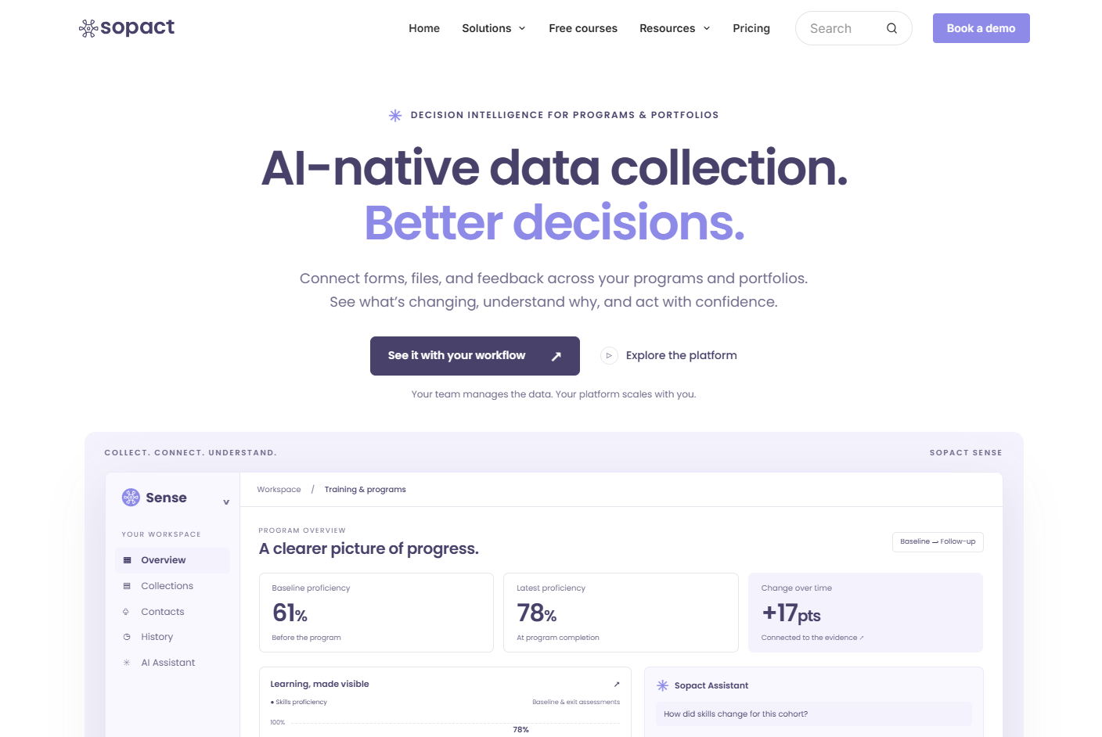
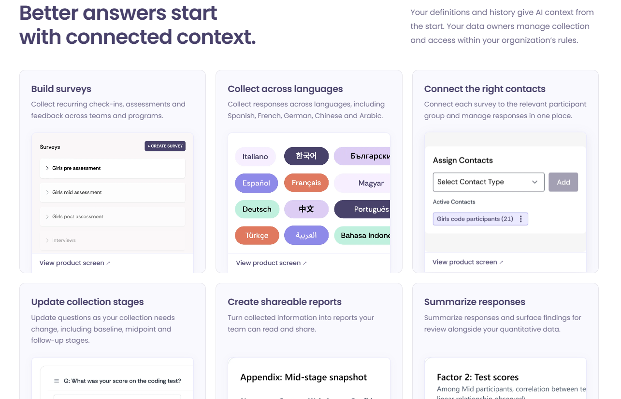
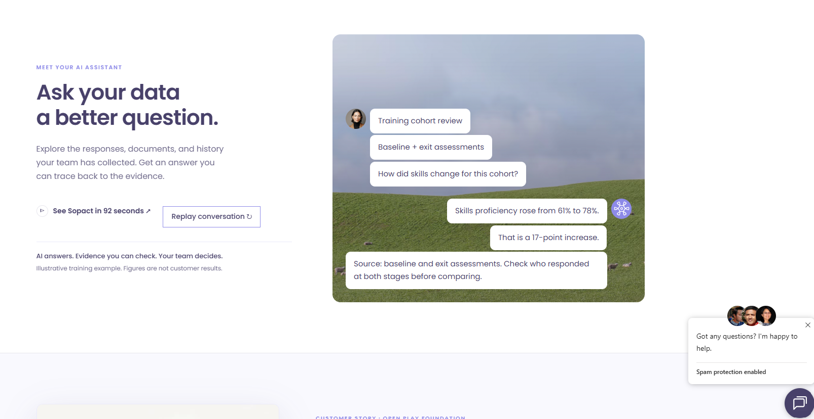
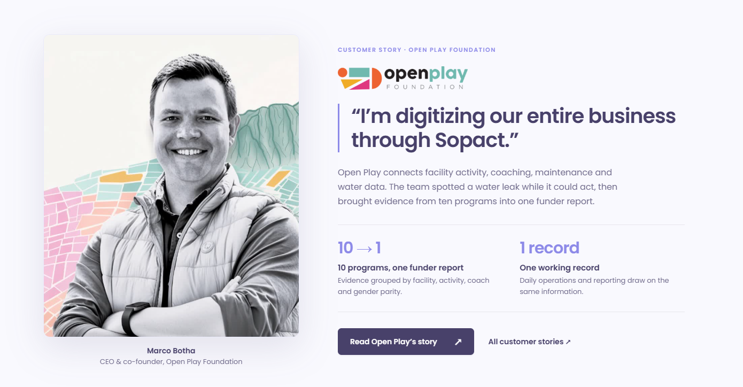
- Bad: Cold SaaS AI hero. "AI-native data collection. Better decisions." over a lavender dashboard mock-up. It is polished, but there are no people, no place and no community context.
- Bad: 6-card feature grid. "Build surveys", "Collect across languages", "Assign contacts", "Update collection stages". The page foregrounds admin and survey mechanics over human outcomes.
- Good: Conversational AI assistant over a natural landscape. "Ask your data a better question" shows plain-language questions answered against a green field, with clear guardrails ("AI answers. Evidence you can check. Your team decides.").
- Good: Open Play customer story card. It has a real leader's face (Marco Botha), a concise transformation quote ("I'm digitizing our entire business through Sopact."), a 10 → 1 programmes-to-report metric and a clear "Read Open Play's story" CTA. This is the testimonial model Greenlight needs.

3. Next Generation (South Africa): Website Audit
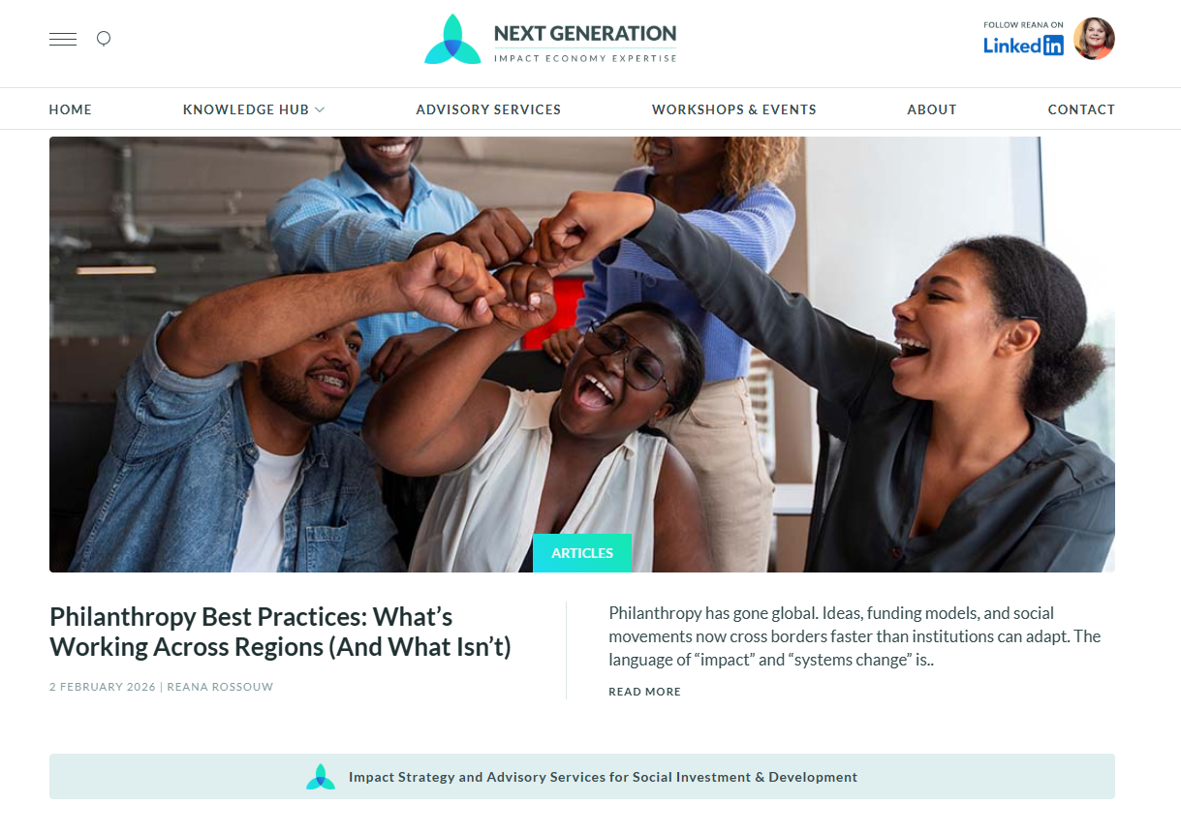
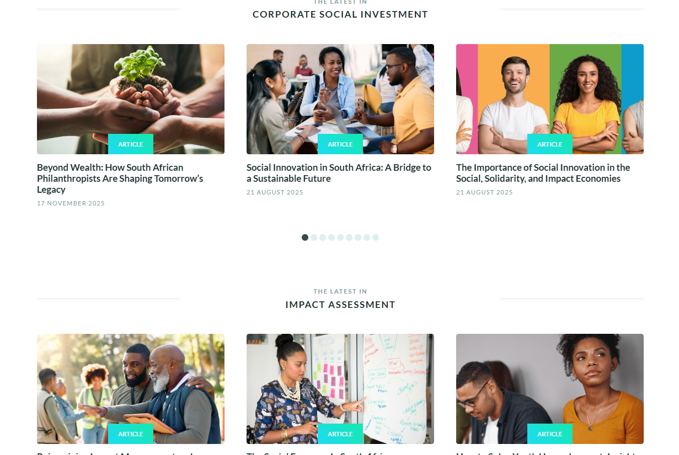
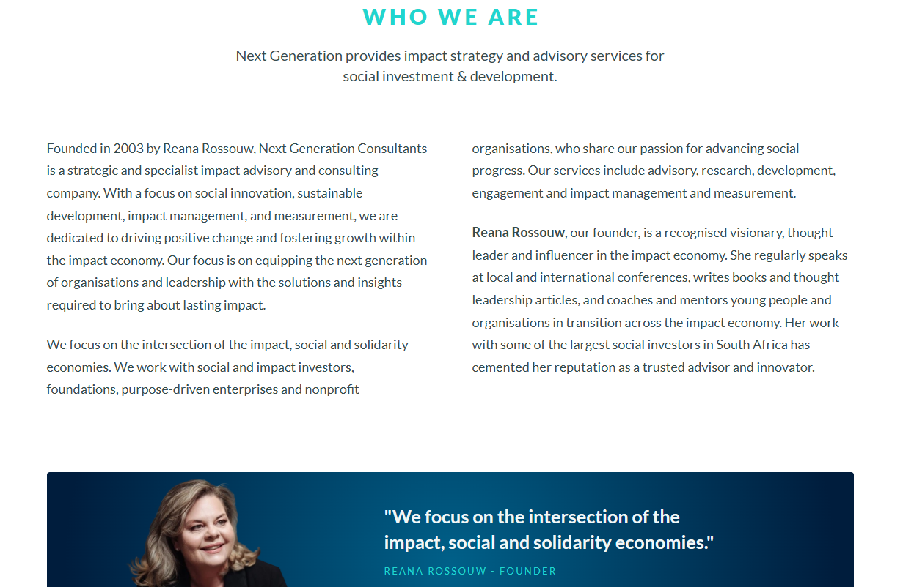
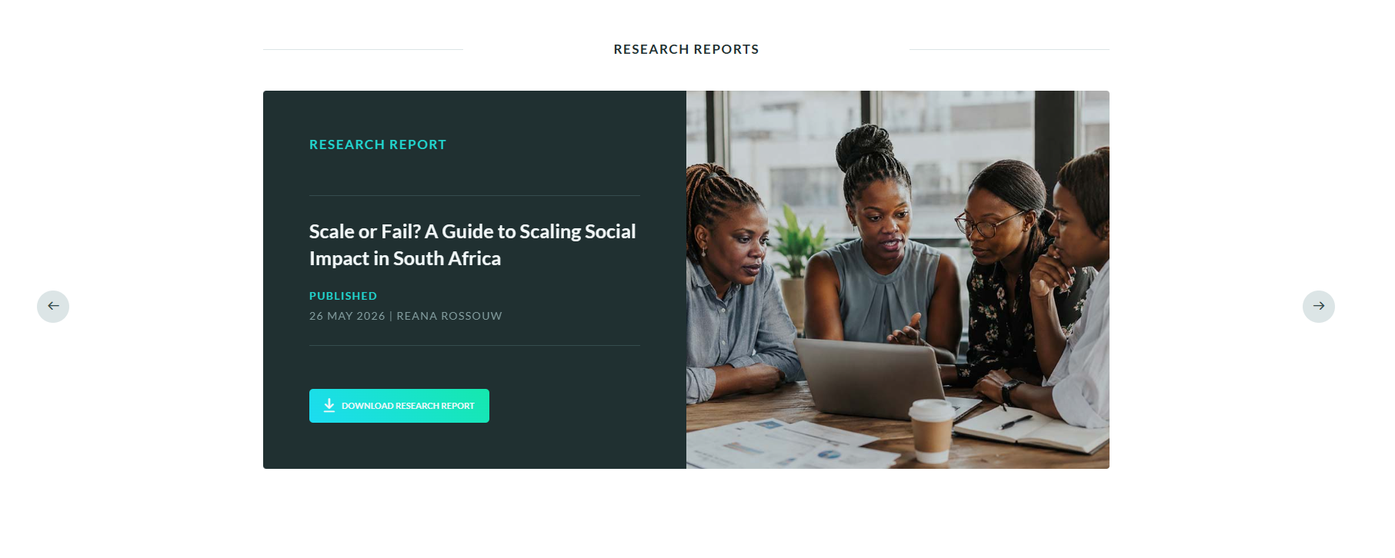
- Bad: Corporate fist-bump stock hero and nav clutter. A generic stock photo of a team fist bump, with the founder's personal "Follow Reana on LinkedIn" banner placed inside the global navigation.
- Bad: Generic CSI stock carousel. It shows seedling-in-hands and sticky-note workshop photos under "Corporate Social Investment", the visual clichés of the sector.
- Good: Grounded founder presence. "Who We Are" puts Reana Rossouw front and centre, founded 2003, with 20+ years of local credibility and a clear pull-quote: "We focus on the intersection of the impact, social and solidarity economies."
- Good: Open-access research reports. Downloadable reports such as "Scale or Fail? A Guide to Scaling Social Impact in South Africa" show tracked sector data and position the firm as a knowledge leader.

4. Coady Institute (International): Website Audit
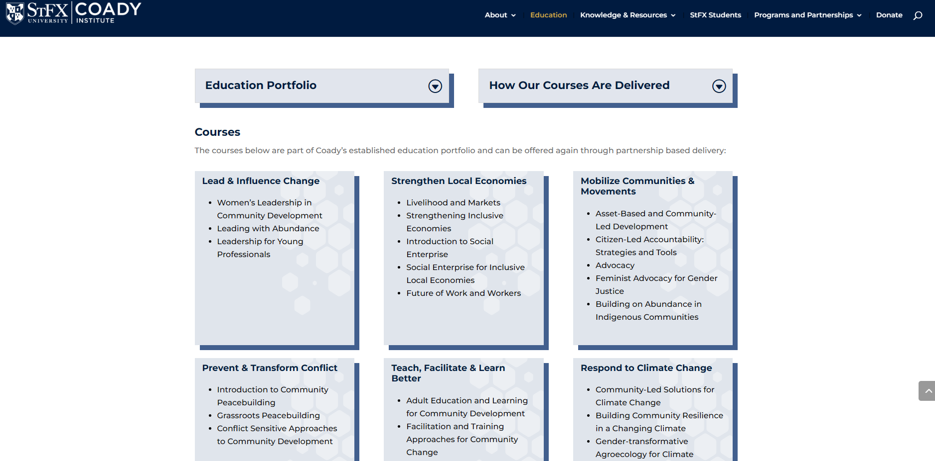
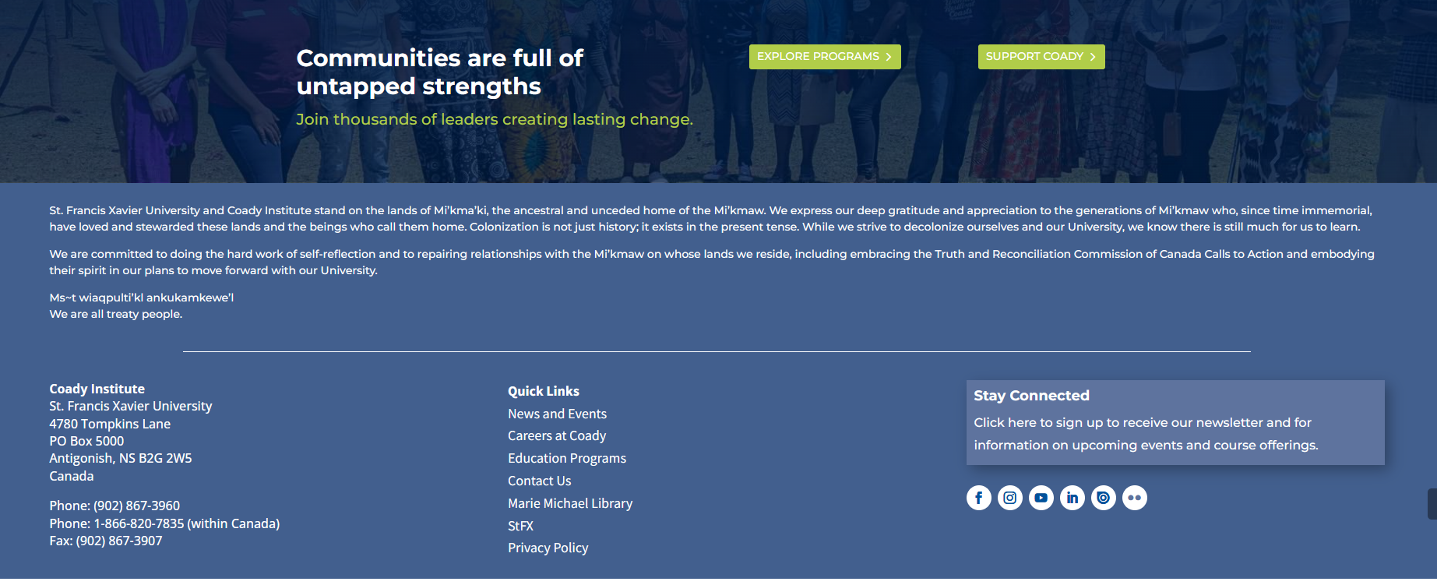
- Bad: Academic course grid and bureaucratic navigation. A PowerPoint-style grid of course boxes, nested "Education Portfolio" / "How Our Courses Are Delivered" dropdown tabs, deep mega-menus and a passive, administrative tone.
- Good: Asset-based headline. "Communities are full of untapped strengths. Join thousands of leaders creating lasting change." It is strength-first language, not deficit framing.
- Good: Authentic practitioner photography. It shows real participants in real settings, not stock models.
- Good: Living community of practice. Upcoming events, course registrations and newsletter sign-ups show an active, ongoing community, not a static brochure.

Strategic Comparison: Peer Traps to Avoid vs. Peer Strengths to Adapt
Peer | Trap to Avoid | Strength to Adapt | What It Means for Greenlight Movement
Poverty Stoplight | Literal traffic-light identity and inherited "Stoplight" naming | Validated methodology and global recognition | Credit the methodology proudly, but retire the traffic-light visuals and own a distinct African movement identity.
Sopact | Cold SaaS hero and feature-grid admin mechanics | Human customer story cards with face, hook quote, metric and CTA | Lead with outcomes and people; rebuild testimonials as story cards (face + one-line hook + 79% / 161 / 115k metric + "Read full story").
Next Generation | Corporate stock photography and personal-brand nav clutter | Founder credibility and open-access research reports | Show leadership's track record and publish downloadable impact reports from the 161 analytical reports.
Coady Institute | Academic course grids, nested menus, passive tone | Asset-based headline, real practitioner photos, live events | Write strength-first headlines, use authentic facilitator photography, and show a living Community of Practice (cohorts, learning circles, events).

Strategic Takeaway for Greenlight Movement: No peer combines evidence-grade rigour with human warmth and an active movement feel. Greenlight's site should pair Sopact's story-card clarity and Next Generation's research authority with Coady's strength-first, community-of-practice energy, and leave the traffic lights, stock clichés and admin mechanics behind.

The Greenlight Differentiation: Where We Stand Apart
- Our Offering vs. Peers: Greenlight does not sell software, deliver once-off external audits, or merely hand out surveys. We deliver an accompanied, longitudinal 7-step learning journey (preceded by a strict Fit-for-Purpose qualification gate). By combining ground-up diagnostic rigor with 24+ months of continuous accompaniment, structured reflection, and strict organizational readiness (the 5 Fit-for-Purpose criteria), we achieve what software and surveys alone cannot: 79% second-survey retention and sustained organizational transformation.
- Our Messaging & Tone vs. Peers: While international peers speak in the language of Silicon Valley SaaS dashboards ("impact data at scale") or dry academic research, and local consultants speak in compliance jargon ("B-BBEE scorecard audits"), Greenlight speaks as a dignified, community-rooted, evidence-driven African movement. We elevate participants from surveyed subjects to co-creators of their own developmental roadmaps, and we celebrate implementing partners that possess the institutional courage to learn and adapt.
- Our Look & Feel vs. Peers: Where competitors rely on literal traffic lights, cold tech blues, sterile clinical white, or dense academic layouts, Greenlight embodies modern African vitality and institutional gravitas—grounded in deep forest green, energised by crisp leaf green, and warmed by human stone neutrals.

Visual Competitor Matrix (5-Column Landscape)
To inform Feral Creative’s upcoming visual identity design, the table below maps the visual positioning of our key peers against the proposed aesthetic for The Greenlight Movement:
Visual Dimension | 1. Poverty Stoplight (Global) | 2. Sopact (International) | 3. Next Generation (South Africa) | 4. Coady Institute (International) | 5. The Greenlight Movement (Our Position)
Overarching Aesthetic | Literal NGO diagnostic tool; graphic, utilitarian, traffic-light themed. | Polished B2B SaaS tech portal; corporate, analytical, dashboard-heavy. | Corporate advisory & compliance; formal, dense, ESG-consultancy style. | Academic institution; formal higher-ed university look, text-heavy. | Modern African social movement; dignified, dynamic, relational & evidence-led.
Dominant Colors | Primary traffic light hues: Red (#E53935), Amber (#FFA000), Green (#43A047), neutral white. | Cold corporate tech blues (#0052CC, #172B4D), slate greys, bright cyan accents. | Navy blue, corporate dark slate, corporate gold/amber, conservative white. | University academic blue, muted burgundy/gold, parchment neutrals. | Deep Forest Pine (#034437), Leaf Green (#187A52), Electric Lime (#8DC63F), Celery (#E5EFCA), Warm Stone & Cream (#E5DBCC / #F4F1ED).
Imagery & Photography | Literal poverty imagery, stock-feeling field photos, survey tablet screenshots. | Corporate dashboard UI screenshots, tech stock professionals at laptops, abstract vector nodes. | Corporate boardroom photos, formal business handshakes, generic corporate CSR imagery. | University campus imagery, classroom lecture halls, formal academic workshop groups. | Authentic, dignified South African communities, engaged facilitators, real reflection circles, warm natural light.
Typography & Tone | Basic sans-serif, utilitarian, functional, feels like software documentation. | Geometric tech sans-serif (Inter, Roboto), sharp, clinical, software-first. | Traditional corporate serif and clean sans-serif; formal, risk-averse. | Academic serif and university institutional sans-serif; dense, scholarly. | Confident humanist / geometric display sans-serif (e.g. Cabinet Grotesk / Plus Jakarta) paired with a clean data-grade workhorse.
Visual Weakness / Opportunity | Visually trapped in child-like traffic light metaphor; feels like a survey tool, not a movement. | Cold and impersonal; lacks community heartbeat, human warmth, and local African soul. | Feels like an accounting firm or compliance audit; intimidating for grassroots NPOs. | Feels removed from frontline reality; too academic and slow for fast-paced practitioners. | Owns the white space: balances rigorous data authority with human warmth, dignity, and living movement energy.

🎨 Designer Note & Visual Brief (For Feral Creative):
Slide Deck Layout Prompt: In the client presentation deck, lay this out as a full-bleed 5-column visual mood board comparison. Use the first four columns to display live screenshot samples, color swatches, and photo styles from Poverty Stoplight, Sopact, Next Generation, and Coady Institute. Dedicate the fifth, prominent column entirely to The Greenlight Movement, showcasing our recommended forest/leaf/stone color swatches, mood board imagery (dignified community collaboration in warm African light), and sample typographic hierarchy to demonstrate how Greenlight visually stands out from the entire peer group.

Deliverable 02: Current Brand Assessment

2.1 What They Say vs. What Comes Across
Brand Dimension | What Greenlight Thinks It Says | What Actually Comes Across Today | The Required Pivot
Brand Identity | "We are a dynamic movement transforming communities across South Africa." | "We are a back-office administration unit (Greenlight Office) that runs survey tools." | A unified, member-powered movement driving measurable social change.
Core Offering | "We help organisations continuously learn, reflect, and improve programmes." | "We sell or administer the Poverty Stoplight survey software." | An intentional 7-step learning journey preceded by rigorous Fit-for-Purpose qualification.
Relationship | "We are a long-term partner walking alongside you over 24+ months." | "We provide a diagnostic service once a year." | Relational accompaniment with forced reflection and proven outcomes.
Standard / Quality | "We maintain a rigorous Fit-for-Purpose readiness threshold to protect impact integrity and mutual investment." | "Anyone can download or run our surveys whenever they like." | A selective, high-integrity community of committed, high-performing organisations.
Authority | "We hold one of the richest longitudinal social datasets in Southern Africa." | "We are an NGO asking for support and member fees." | A leading sector authority and thought leader shaping development policy.

2.2 Visual Identity Diagnosis
- The Logo: The current circular mark incorporating the green arrow / light is functional but dated. It suffers from low visual contrast on dark backgrounds and lacks a distinctive, modern digital footprint.
- Color Palette: Dominated by a stark, single-note green. It lacks secondary warmth and sophisticated neutrals, which causes digital touchpoints to feel clinical or reminiscent of environmental/energy campaigns rather than human-centered social transformation.
- Typography: Mixed and inconsistent across decks and web pages (default Arial, Calibri, and generic web sans-serifs). It lacks an authoritative editorial voice.
- Imagery & Representation: Existing images lean toward candid but uncurated snapshots. The brand needs an intentional photography standard that portrays participants with dignity, agency, and pride—avoiding "poverty tourism" tropes while honestly reflecting community context.

Deliverable 03: Audience Analysis & Messaging Matrix
Greenlight Movement engages five distinct stakeholder groups (as mapped in Slide 10 of the Member Presentation). Each group operates with different pressures and requires distinct narrative proof:

Detailed Stakeholder Messaging Matrix

1. NPOs & Social Enterprises (Implementing Members)
- Their Reality: Operating under severe operational and financial strain; suffering from M&E burnout, reporting fatigue, and lack of internal capacity to analyze complex data.
- Current Messaging Disconnect: Greenlight feels like another complex data system to learn, requiring time they don’t have.
- What They Need to Hear: "You don’t need another data system; you need a partner who walks alongside you. We provide the structured reflection, practical tools, and evidence that make your programmes stronger and secure your funding."
- Core Proof Points: 79% retention on second surveys; 161 tailored baseline and impact reports; step-by-step facilitation training; peer learning circles.

2. Funders, Donors & CSI Managers
- Their Reality: Pressured to demonstrate genuine Social Return on Investment (SROI); frustrated by vanity metrics (e.g., "1,000 food parcels handed out") that show no long-term behavioral change.
- Current Messaging Disconnect: View Greenlight as a single implementing charity competing for grant money rather than a strategic infrastructure partner.
- What They Need to Hear: "Fund the journey, not just the snapshot. Greenlight gives your portfolio the longitudinal evidence and organizational resilience needed to prove sustainable impact over time."
- Core Proof Points: Multi-year tracking; Fit for Purpose screening ensuring grant readiness; independent facilitators ensuring objective data; portfolio-level insights.

3. Government & Public Sector Agencies
- Their Reality: Need scalable, reliable ground-up data to guide social development policies, community health interventions, and municipal resilience strategies.
- Current Messaging Disconnect: View Greenlight as an isolated non-profit initiative without institutional or policy-grade scale.
- What They Need to Hear: "Granular, community-validated intelligence that reveals where public interventions succeed, where systemic barriers persist, and how to allocate resources effectively."
- Core Proof Points: 115,000+ localized assessments across urban and rural South Africa; multidimensional poverty mapping; standardized longitudinal indicators.

4. Grassroots & Community Organisations
- Their Reality: Deeply protective of community trust; wary of external researchers extracting data without leaving tangible value behind.
- Current Messaging Disconnect: Fear that surveys will reduce vulnerable families to statistical numbers or create unfulfilled expectations.
- What They Need to Hear: "Data owned by the community, for the community. Our self-diagnostic approach creates a safe space for families to recognize their own strengths, set their own priorities, and take charge of their future."
- Core Proof Points: The 5 Fit-for-Purpose Readiness Criteria, accompanied reflection cycles, 79% second-survey retention rate, and 161 formal analytical reports.

5. Academic & Research Partners
- Their Reality: Dedicated to methodological rigor, ethical data collection, and publishable longitudinal evidence on social mobility.
- Current Messaging Disconnect: Greenlight’s rigorous methodology is obscured by informal marketing language.
- What They Need to Hear: "One of Africa’s richest longitudinal datasets on multidimensional poverty, collected under standardized, ethically controlled conditions with high cohort retention."
- Core Proof Points: Standardized metrics across 165 organisations; 10-year longitudinal depth; formal case studies and sector-wide knowledge exchange.

Deliverable 04: Direction & Strategic Framework

4.1 Master Brand Architecture
To build lasting authority and eliminate market confusion, Greenlight will adopt a Monolithic ("Branded House") Architecture. Everything the organisation does will live under the single umbrella of The Greenlight Movement:
- Master Brand (The Anchor): The Greenlight Movement
The sole legal, operational, and public-facing identity. It retires "The Greenlight Office" completely across all domains, social channels, collateral, email signatures, and legal contracts.
- Flagship Convening Brand (Endorsed Entity): The Greenlight Conference
Held biennially (next in May 2027), the conference is framed as an initiative powered by The Greenlight Movement. It is the national learning stage where members, donors, and policy makers gather to share longitudinal impact insights.
- Proprietary Methodologies & Frameworks (Branded Assets):
Rather than spinning off separate sub-brands or products, Greenlight’s core offerings are branded as proprietary intellectual property under the Movement:
  - The 7-Step Member Learning Journey: The structured, 24-month accompanied pathway through baseline surveys, reflection, action, second surveys, and case studies.
  - The Fit-for-Purpose Readiness Framework: The proprietary 5-point qualifying standard (Leadership, Learning Mindset, Resourcing, Program Muscle, Clear Purpose) that guarantees member success.
  - The Greenlight Longitudinal Database: The aggregate dataset of 115,000+ multidimensional poverty surveys across South Africa.

4.2 The Four Brand Pillars
Derived directly from the organisation’s hard-won operational insights between 2023 and 2026, these four pillars form the bedrock of all future Greenlight messaging, campaigns, and member engagements:
- Pillar 01: Evidence over Raw Measurement
  - Core Principle: Measurement alone does not create impact. Surveys and dashboards are meaningless without the institutional capacity and willingness to interpret and act on findings.
  - Strategic Proof: Shifted from an open survey dispensary to delivering 161 formal analytical reports (134 baseline, 67 impact reports) that translate multidimensional survey data into concrete organisational strategy.
- Pillar 02: Intentional Readiness & Mutual Fit
  - Core Principle: Sustainable impact requires genuine readiness. Greenlight does not work with everyone; we partner exclusively with organisations that meet our rigorous qualification criteria.
  - Strategic Proof: The 5-Point Fit-for-Purpose framework ensures alignment of leadership, resources, long-term mindset, and execution muscle—protecting both the member’s investment and Greenlight’s team capacity.
- Pillar 03: Accompanied Reflection & Human Learning
  - Core Principle: Data requires a human companion. We combine quantitative diagnostic rigor with relational accompaniment—holding the member’s hand through forced reflection, structured learning, and course correction.
  - Strategic Proof: Achieving a 79% second-survey completion rate (up from 22% in 2023) by walking alongside member leadership teams over 24+ month learning cycles.
- Pillar 04: Longitudinal Depth & Collective Momentum
  - Core Principle: We choose deep, transformative impact over wide, superficial reach. By connecting 165+ like-minded organisations, we aggregate grassroots evidence to influence national development policy and funder practice.
  - Strategic Proof: A growing network of 165+ committed member organisations, 115,000+ completed ground-up surveys, and the biennial national Greenlight Conference serving as the national sector benchmark.

4.3 Brand Tone of Voice Guidelines
We Are | We Are Not | How It Translates in Copy
Rigorous & Evidence-Led | Academic, dry, or clinical | We lead with real numbers and verifiable findings, but explain them in clear, human, actionable language.
Relational & Accompanitive | A detached SaaS platform or vendor | We talk about "walking alongside", "learning together", and "partnering for the long haul."
Dignified & Empowering | Paternalistic, pity-driven, or patronising | We never portray communities as helpless victims. Participants are active agents diagnosing their own journeys.
Clear & Decisive | Vague, apologetic, or bureaucratic | We state our readiness criteria and learning commitments boldly. We celebrate organisations with the leadership and courage to reflect and adapt.

4.4 Master Impact Statistics (The Single Source of Truth)
To eliminate conflicting numbers across digital channels, all upcoming brand assets will adhere strictly to this standardized proof sheet:
- 165+ Member Organisations actively engaged across South Africa.
- 115,000+ Ground-Up Surveys completed with participants and families.
- 79% Longitudinal Retention Rate (Second-survey completion, up from 22% in 2023).
- 161 Formal Analytical Reports delivered (134 baseline, 67 impact reports).
- Biennial Greenlight Conference (Next edition: May 2027).

4.5 Visual Rebrand Brief (Creative Guidelines for Feral Creative)
- Primary Visual Direction:
  - Digital-First Modern Movement: The identity moves decisively away from generic "ecology/recycling" tropes and juvenile "traffic light" literalism. It embodies a modern, data-empowered African social movement balancing institutional authority with living grassroots vitality.
  - Curated Color Palette System (Feral Creative Master Swatches):
    - Primary Brand Anchor (Deep Forest Pine): #034437 — Imparts deep institutional weight, longevity, and grounded authority.
    - Supporting Deep Neutrals (Typography & Contrast): Deep Black (#0C0D12) and Charcoal Slate (#33353A) for high-contrast, razor-sharp digital reading and editorial elegance.
    - Vitality & Progress (Mid-Tone Green): #187A52 — Crisp leaf green representing growth, active movement, and forward momentum.
    - Momentum & Action Accent (Electric Lime / Chartreuse): #8DC63F — A high-energy, contemporary highlight hue (used selectively for key callouts, milestones, and active emphasis).
    - Soft Organic Tints (Backgrounds & Data Shading): Soft Celery / Pistachio (#E5EFCA) — Clean, human tint for card backgrounds, secondary tags, and metric containers.
    - Warm Earth & Stone Neutrals (Approachability & Dignity):
      - Warm Camel / Sand Accent: #BCA382
      - Warm Stone / Putty Neutral: #E5DBCC
      - Parchment Cream / Soft Off-White: #F4F1ED (replaces harsh, clinical white to provide warmth, dignity, and high digital accessibility).
    - (Note: Connectiv logo gold remains strictly contained to Connectiv’s credit and is excluded from the Greenlight master palette).
  - Typography System:
    - Headings: Modern, confident geometric or humanist display sans-serif with strong structural character (e.g., Cabinet Grotesk, Plus Jakarta Sans, or Archivo).
    - Body & Data: Highly readable, neutral workhorse sans-serif optimized for reporting tables, survey analytics, and digital reading (e.g., Inter, Public Sans).
  - Iconography & Diagram Language:
    - Continuous line motifs symbolizing the 7-step Member Learning Journey (anchored by the Fit-for-Purpose qualification gate), iterative cycles, and interconnected networks.
    - Data visualization components designed with clarity, avoiding clutter.

The Way Forward: Rebrand Implementation Packages
Once this brand audit sets the strategic foundation, Feral Creative has structured three clear implementation pathways to bring The Greenlight Movement’s new identity to life—scaled according to operational ambition and asset depth.
(Full interactive portal available at: www.feralcreative.me/greenlight001)

01 The Rebrand Packages
Package Details | Starter Tier | Standard Tier (Recommended) | Comprehensive Tier
Investment | R31,000 | R36,000 | R54,000
Strategic Focus | Essential core identity reboot for immediate digital consistency. | Complete day-to-day operational toolkit for presentations and social comms. | Full-scale institutional rollout with motion assets and high-impact promo video.
New Logo Development | Included (Primary, secondary, and icon marks) | Included (Primary, secondary, and icon marks) | Included (Primary, secondary, and icon marks)
Look + Feel Development | Included (Typography, color system, graphical styling) | Included (Typography, color system, graphical styling) | Included (Typography, color system, graphical styling)
Mini Brand Guide | Included (Rules of usage, color codes, typography spec) | Included (Rules of usage, color codes, typography spec) | Included (Rules of usage, color codes, typography spec)
Letterhead | Word document template | Word document template | Word document template
Email Signature | Custom branded HTML / graphic signature | Custom branded HTML / graphic signature | Custom branded HTML / graphic signature
Social Media Banners | 3 platforms (Facebook, LinkedIn, X/other) | 3 platforms (Facebook, LinkedIn, X/other) | 3 platforms (Facebook, LinkedIn, X/other)
Presentation Deck | — | 10-slide PowerPoint master template deck | 15-slide PowerPoint master template deck
Social Media Templates | — | 4x social media templates (in two sizes) | 8x social media templates (in two sizes)
Video Production | — | — | 1x Opener Promo Video (20–30 sec in two sizes)

Deliverable 05: Presentation Deck Outline (Client Handover)
This structure translates the audit findings into a compelling client walkthrough deck:
- Slide 01: Title & Strategic Purpose
  - Headline: The Greenlight Movement: Brand Audit & Strategic Positioning Blueprint.
  - Subtitle: Bridging Our Past Achievements with Our Future Authority.
- Slide 02: Executive Reality Check
  - Theme: The organisation has transformed; the brand must catch up.
  - Focus: The journey from "The Greenlight Office (Survey Vendor)" to "The Greenlight Movement (Learning Ecosystem)."
- Slide 03: The Name Resolution
  - Theme: Retiring the "Office" identity.
  - Focus: Why "The Greenlight Movement" is the only brand that matches their ambition.
- Slide 04: The 2023–2026 Transformation in Numbers
  - Theme: Evidence of deep growth.
  - Focus: 22% → 79% second surveys; 115k+ assessments; 161 impact reports; 5-Point Fit-for-Purpose criteria.
- Slide 05: Competitive Landscape & Market White Space
  - Theme: Where Greenlight stands in Africa and the world.
  - Focus: Positioning vs. Poverty Stoplight, Sopact, Next Generation, and Coady Institute.
- Slide 06: Visual Competitor Mood Board (5-Column Landscape)
  - Theme: How the peers look vs. how Greenlight can shine.
  - Focus: Contrasting the cold tech blues and literal traffic lights of peers against Greenlight's vibrant deep forest green, crisp leaf, and warm stone aesthetic.
- Slide 07: SECTION BREAKER / TRANSITION
  - Headline: "Okay... back to the depressing stuff...."
  - Subtitle / Speaker Note: "We’ve just looked at our incredible market potential, our peers, and our clear visual white space. Now it’s time to take an honest, unflinching look at what our current public touchpoints actually look like today—and rip the existing brand a healthy new one."
- Slide 08: Deliverable 02: Current Brand Assessment (What They Say vs. What Comes Across)
  - Theme: The communication disconnect.
  - Focus: The contradiction between a forward-looking relational movement and fragmented, dated public communications.
- Slide 09: Cross-Platform Digital Audit & Visual Diagnosis
  - Theme: Digital touchpoint autopsy.
  - Focus: Website disconnect, Facebook inactivity, YouTube dormancy, and visual traffic-light literalism.
- Slide 10: LinkedIn Channel Audit (Specialist Findings by Glynis Abrahams, Connectiv)
  - Theme: B2B engagement breakdown.
  - Focus: Algorithm penalties, lack of video, missing leadership voices, and low engagement.
- Slide 11: Deliverable 03: Audience Analysis & Messaging Matrix
  - Theme: Speaking to those who matter most.
  - Focus: Distinct value propositions for NPOs, Donors/CSI, Government, Grassroots, and Researchers.
- Slide 12: Deliverable 04: Master Brand Architecture & The 4 Core Brand Pillars
  - Theme: The strategic foundation.
  - Focus: The monolithic master brand structure, 7-Step Journey, 5 Fit-for-Purpose criteria, and the 4 Pillars (Evidence, Readiness, Accompaniment, Momentum).
- Slide 13: Tone of Voice & Personality
  - Theme: How The Greenlight Movement speaks.
  - Focus: Rigorous, relational, dignified, and decisive voice principles.
- Slide 14: Visual Identity Direction & Rebrand Runway
  - Theme: Setting the creative foundation for Feral Creative’s rebrand.
  - Focus: Master palette (Deep Forest, Crisp Leaf, Warm Stone), typography pairings, dignified photography style, and roadmap to the May 2027 Conference.
- Slide 15: The Way Forward (Three Rebrand Pathways)
  - Theme: Bringing the strategy to life step-by-step.
  - Focus: Presentation of Feral Creative’s Starter (R31,000), Standard (R36,000), and Comprehensive (R54,000) packages, linked to the client portal (www.feralcreative.me/greenlight001).

Report compiled by Feral Creative for The Greenlight Movement.

